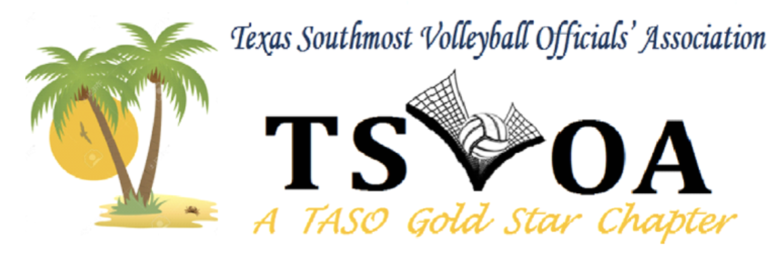
2023  TSVOA Board  President  Rolando Flores  Vice-President  Bonnie A Salazar  Secretary  Debbie Esparza  Treasurer  Beatris Carranza  Assignor  Tommy Bermudez  Parliamentarian  Benny Villarreal  SGT at ARMS  Julio Rodriguez |  | TSVOA 1st CHAPTER MEETING  JAMES PACE HIGH SCHOOL  MAY 17, 2023 (6:30 PM)  AGENDA  President  - Approved Minutes  - Vice-President Report  - Assignor Report  - Treasurer Report  - Secretary Report  - Sargent of Arms  - Parliamentarian  - Old Business  - New Business  - Adjourn

