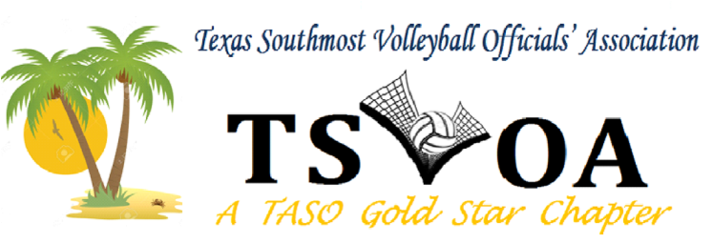
Minutes JULY 26, 2023
PACE HIGH SCHOOL. GYM

Meeting Called to Order by President Rolando Flores.

Board members that were present were Beatris, Bonnie, Benny, Tommy., Debbie, Rolando, Absent was Julio Rodriguez.

Approval of Minutes From July 12, 2023. Juan Garza motioned to approve the minutes, Seconded by Yadira Reyes. The motion carried.

President Report
Corpus Christi Clinic:
Rolando spoke about the clinic and the number of members we had that attended.

Discussion from Panel of Coaches: Two coaches addressed the members over Rolando's questions.
Elizabeth A Guerra and Lpri Marez stressed how we need to be professional and non-bias. Remember that their lively hood depends on the teams' performance; they get caught up in the game and are very passionate.
Officials must be approachable and not so defensive—the importance of being early to the games, understanding the level that officials are officiating, and making the calls needed to improve their skills.

Secretary Report: Debbie spoke about how well the San Benito Tournament went and that we made 700.00 dollars. Please read the TSVOA's emails.

Treasurer Report Bea Carranza reviewed account balances as of July 26, 2023.
Balance in Bank Account 8135.76, and 2,500 of this amount assigning fees.

Assigner Report: Tommy Bermudez went over Accepting your scrimmages in Arbiter Sports
Juan Porteous asked, "What will happen to those who do not officiate scrimmages"? Jose Herrera stated that TASO mandates that you have to officiate scrimmages to be a member in good standing. Tommy addressed both individuals that the board would look into TASO guidelines, and as a board, we will discuss the individuals.
Tommy also told the members that he would begin assigning on Aug 5 or 6. All members need to do the following:
Please update your contact information.
Please go into the calendar and mark off the days you cannot officiate.
Create an ArbiterPay Account. At www.arbiterpay.com

Vice President Report: Bonnie asked if any had not picked up their books to please stop by after the meeting.

Training: Tiffany led the group that was there early for training on proper procedures for signals with everyone on the court.
Tiffany passed handouts over alignment and placed individuals on the court to demonstrate—illegal Alignment court positions.

Motion to adjourn was made by Mario Blanco and Seconded by Juan Garza at 7:30 pm.

